Summary - Int 2, Group B, 𝚫𝚫G Version

Inbal Lorena Eshel

03/02/25

# *Intermidiate 2*

### Model 3P

| formula | R.sq | Q.sq | MAE |
| --- | --- | --- | --- |
| ddg ~ NPA_31 + diff_NBO_10_7 + Dist.10..8. | 0.724 | 0.600 | 0.327 |
| ddg ~ NPA_10 + NPA_31 + Dist.10..8. | 0.718 | 0.594 | 0.336 |

***Multicollinearity check***

|  | x |
| --- | --- |
| NPA_31 | 1.481 |
| diff_NBO_10_7 | 2.421 |
| Dist.10..8. | 1.811 |

***Scaled Coefficients:***

|  | Estimate | Std. Error | t value | Pr(>|t|) |
| --- | --- | --- | --- | --- |
| (Intercept) | 1.018 | 0.065 | 15.606 | 0.0000000 |
| NPA_31 | 0.590 | 0.080 | 7.334 | 0.0000000 |
| diff_NBO_10_7 | 0.303 | 0.103 | 2.942 | 0.0060135 |
| Dist.10..8. | -0.391 | 0.089 | -4.394 | 0.0001144 |

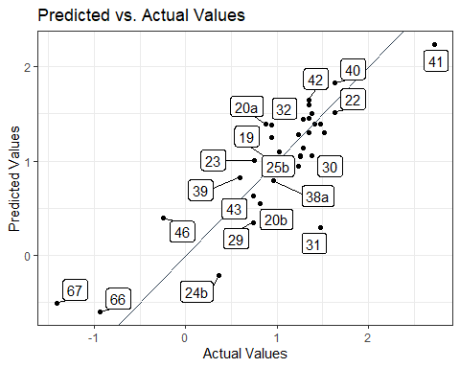

### Model 4P

| formula | R.sq | Q.sq | MAE |
| --- | --- | --- | --- |
| ddg ~ NPA_31 + diff_NBO_32_30 + Total_1 + Dist.10..8. | 0.751 | 0.635 | 0.327 |
| ddg ~ NPA_10 + NPA_31 + Dist.10..8. + B1_3_9 | 0.788 | 0.594 | 0.295 |

***Multicollinearity check***

|  | x |
| --- | --- |
| NPA_31 | 1.411 |
| diff_NBO_32_30 | 1.515 |
| Total_1 | 1.277 |
| Dist.10..8. | 1.234 |

***Scaled Coefficients:***

|  | Estimate | Std. Error | t value | Pr(>|t|) |
| --- | --- | --- | --- | --- |
| (Intercept) | 1.018 | 0.063 | 16.166 | 0.0000000 |
| NPA_31 | 0.382 | 0.076 | 5.041 | 0.0000191 |
| diff_NBO_32_30 | 0.227 | 0.079 | 2.887 | 0.0070282 |
| Total_1 | -0.218 | 0.072 | -3.019 | 0.0050432 |
| Dist.10..8. | -0.313 | 0.071 | -4.408 | 0.0001162 |